**CPE1140**

|  |  |  |
| --- | --- | --- |
| **1.** | **LAB NUMBER:** | **3** |
| **2.** | **TITLE:** | **Parallel DC Circuit Analysis** |
| **3.** | **OBJECTIVES:** |  |

After completing this lab, the student will be able to:

1. measure the total resistance of a parallel circuit,
2. measure the total and branch currents,
3. verify that in a parallel circuit, all resistors have the same voltage drop,
4. verify Kirchhoff’s Current Law,
5. verify the Current Divider Rule,
6. calculate the power dissipated in each resistor.

**4. EQUIPMENT:**

DC Power Supply: Uni PS-2303

Digital Multimeter: RIGOL DM 3058E

Experimenter board (C.A.D.E.T.) or a Breadboard

Multisim Software

**5. COMPONENTS:**

1 - 510 Ω ½ watt 5% Resistor

1 – 1k Ω ½ watt 5% Resistor

1 - 2k Ω ½ watt 5% Resistor

**6. TEXT REFERENCE:**

Circuit Analysis: Theory and Practice (5th Edition): A.H. Robbins and W.C. Miller

Section 2.6: Measuring Voltage and Current

Section 3.7: Measuring Resistance – the Ohmmeter

Section 4.1: Ohm’s Law

Section 4.3: Power

Chapter 6: Parallel Circuits

**7. PRE-LAB ASSIGMENT:**

Study the circuit in Fig.1 then do the following calculations:

Figure 1

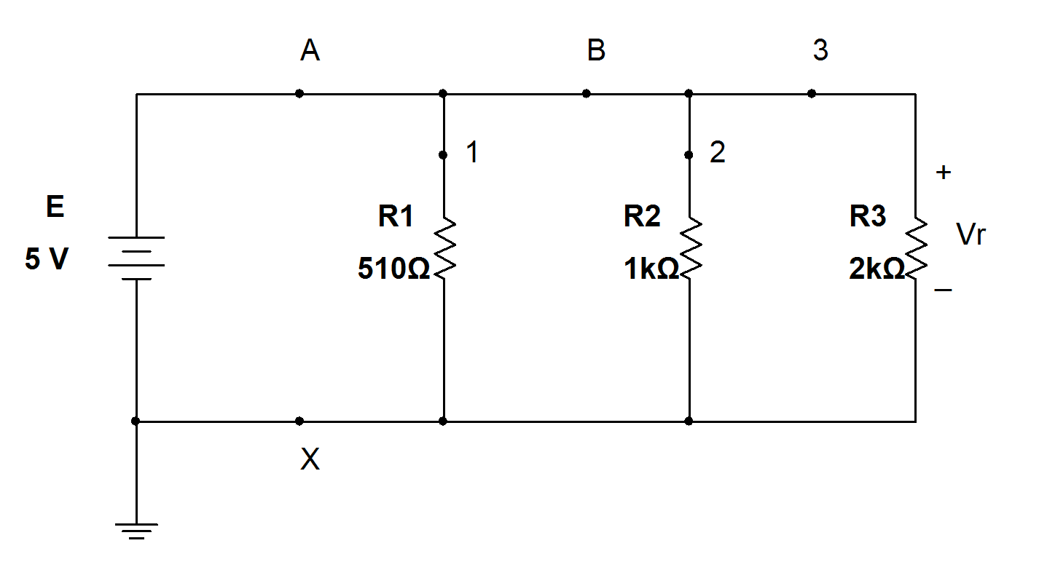

N1 N2

Table 1:

|  |  |  |
| --- | --- | --- |
| Resistor | Current through R (mA) | Power dissipated (mW) |
| R1: 510 Ω | I1 = 9.803 | P1 = 49.019 |
| R2: 1000 Ω | I2 =5.000 | P2 =25.000 |
| R3: 2000 Ω | I3 =2.500 | P3 =12.500 |

|  |  |
| --- | --- |
| Rt = 288.952 | Ω |
| IA (Rt) = 17.303 | mA |
| IA (Sum) =17.303 | mA |

1. Refer to your textbook, use a suitable formula to calculate the total resistance Rt for this parallel circuit. Record your result in Table 1.
2. In a parallel circuit, each resistor receives the same voltage equal to the source voltage E across it. Calculate the current that flows through each resistor using Ohm’s Law. Record your result in Table 1.
3. The source current IA can be found in two ways:

IA = E/Rt (IA (Rt))

or IA = I1 + I2 + I3 (IA (Sum)) Calculate

IA using both methods. Record your results in Table 1.

1. Since the voltage across each resistor is E, calculate the power dissipated by each resistor using the formula: . Record your results in Table 1.

**8. MEASUREMENTS:**

**A- Resistance Measurement:**

a) Build the circuit of Fig.1 without the source E attached. Set the DMM to measure resistance (Ω) then measure the total resistance R123 (of the resistance sequence R1, R2, R3). Record you results in Table 2.

|  |  |  |
| --- | --- | --- |
| Resistor (Ω) | Measured (Ω) | Resistor tolerances (­Ω) |
| 510 | 521.20 | 484.500 – 535.500 |
| 1000 | 987.52 | 950.000 - 1050.000 |
| 2000 | 1965.19 | 1900.00 – 2100.000 |

Table 2:

R123 =290.62Ω

R321 =290.63Ω

b) Interchange the location of R1 (510 Ω) and R3 (2KΩ). Measure the total resistance again (R321). Record your result in Table 2

c) Are the two results (R123 and R321) different?

d) How are these results compared with the calculated Rt in Table 1? Is the difference within the 5% tolerance of the resistors?

**B- Voltage Drop Measurement:**

e) Locate the **fixed 5V** source on the power supply then connect this source to the parallel circuit with sequence R1, R2, R3. Set the DMM to measure DC voltage. Measure the source voltage E and record your result in   
Table 3.

Table 3:

|  |
| --- |
| E =5.0465 (V) |
| VR1 =5.0458(V) |
| VR2 =5.0072(V) |
| VR3 =5.0429(V) |

f) Measure the voltage drop across each resistor, place the DMM probes in correct positions so that the readings are positive. Record your results in Table 3.

g) Compare the measured values of E to the VR’s.

**C- Source and Branch Currents Measurements:**

h) Set the DMM to read DC current then measure currents at locations **A, B, X, 1, 2, 3** (Fig. 1). Record your results in Table 4.

Table 4:

|  |
| --- |
| IA =17.3191mA |
| IB =7.6565mA |
| IX =17.3225 mA |
| I1 =9.341mA |
| I2 =5.0986mA |
| I3 =2.5330mA |

i) Compare these results to those of Table 1. j) Compare:

IA and IX

(Node N1) IA and (IB + I1) (Node N2) IB and (I2 + I3)

**D- Multisim Simulations:**

k) Create a Multisim circuit (similar to Fig. 1) with the followings:

1) One Voltmeter to measure voltage VR.

2) Six Ammeters to measure source and branch currents (at points

**A, B, X, 1, 2, 3**).

**9. LAB REPORT REQUIREMENT:**

Your team’s Lab Report should contain the followings:

**A Cover Page** with Lab Number, Lab Title, Team members’ Names and Date.

**Result Pages** with:

1. **Resistance Measurement:**

Result:

Show a copy of Table 2.

Discussions:

1. Answer questions 8 (c,d).
2. What conclusion can you make about the locations of the resistors on the value of the total resistance?
3. **Voltage Drop Measurement:**

Result:

Show a copy of Table 3.

Discussions:

What conclusion can you make about the source voltage E and the voltage drops VR1, VR2, VR3?

**C- Source and Branch Current Measurement:**

Results:

Show a copy of Table 4.

Discussions:

1. Answer 8(i) with Multisim currents.
2. Answer 8(j)

**D- Power Study:**

Discussions:

From the results in Table1 of power dissipated in each resistor, conclude if the “1/2 watts” rating is acceptable for the resistors used.

**E- Conclusions:** (*it helps to compare your prelab with measured results*)

1. What conclusion can you make about Kirchhoff’s Current Law?

2. What conclusion can you make about Current Divider Rule?

3. Are all the Lab objectives met? Explain if some are not.

**Appendix:** Attach a printout of **Multisim** simulation and all **Pre-Lab calculations**.